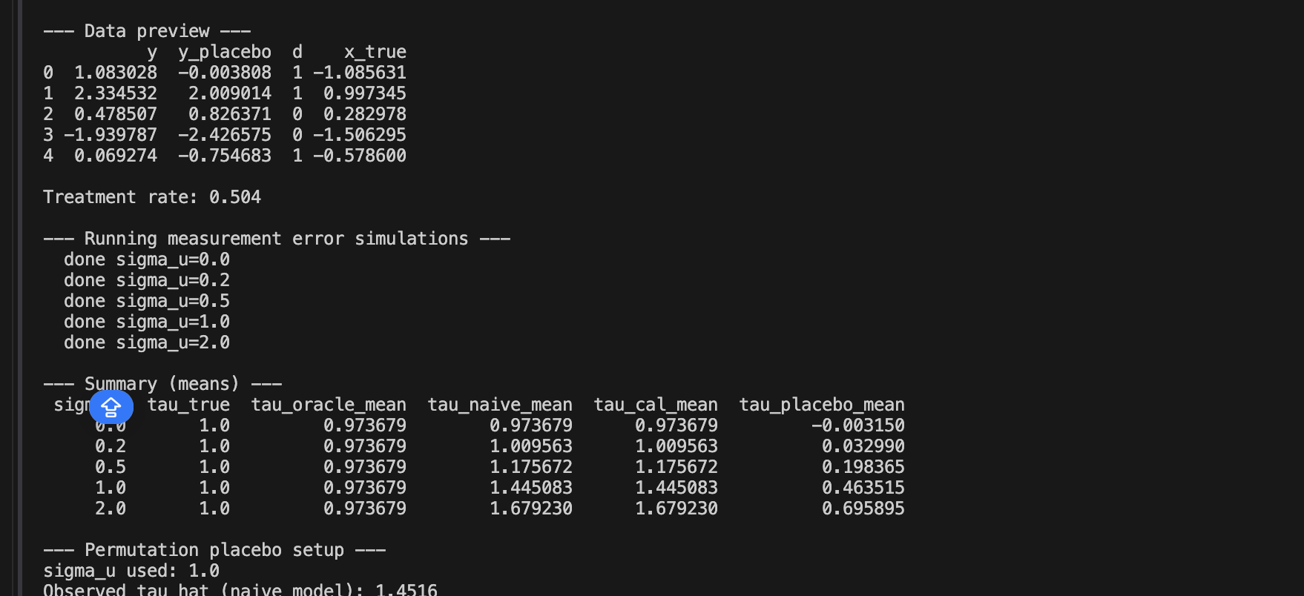

Measurement error represents the discrepancy between an observed value and its true value. When such errors occur within a predictor, they alter the relationship between predictors and outcomes by affecting the predictor's coefficient. However, measurement error in confounding variables introduces even greater bias into the model by impacting the treatment effect, raising significant concerns regarding the actual efficacy of the stimuli.

Applied question 1

sigma_u | tau_oracle_mean | tau_naive_mean | tau_cal_mean | beta_oracle_mean | beta_naive_mean | beta_cal_mean
0 | 1.00351171944878 | 1.00351171944878 | 1.00351171944878 | 0.969251392046823 | 0.969251392046823 | 0.969251392046822
0.2 | 1.00351171944878 | 1.03806513827131 | 1.03806513827131 | 0.969251392046823 | 0.923975362790038 | 0.959196288946933
0.5 | 1.00351171944878 | 1.18092721379579 | 1.18092721379579 | 0.969251392046823 | 0.746707026176213 | 0.929576212692185
1 | 1.00351171944878 | 1.42127687767029 | 1.42127687767029 | 0.969251392046823 | 0.442006025512262 | 0.884513675568547
2 | 1.00351171944878 | 1.64336574097344 | 1.64336574097344 | 0.969251392046823 | 0.166775397139499 | 0.813821315655548

The analysis reveals distinct patterns between the tau and beta files regarding measurement error and treatment effect estimates. In the tau file, as measurement error increases, the naive estimate for the treatment effect rises because the confounder is measured with errors; this creates residual confounding that causes an overestimation of the effect. However, when the oracle model utilizes true confounders, the measurement error is represented by a horizontal line that closely aligns with the true value, signaling that confounding variables have been effectively controlled.

In contrast, the beta file illustrates that increasing measurement error causes the naive treatment effect estimate to diminish toward zero. This trend highlights how measurement errors weaken the connection between observed and true values, whereas the oracle estimate consistently maintains proximity to the true treatment effect. Ultimately, the fundamental distinction lies in the fact that the oracle estimand produces unbiased results by using the true confounder, while the naive estimand relies on a noisy proxy, resulting in biased treatment effects and the attenuation of the confounder's influence.

Question2

validation_share | tau_naive_mean | tau_cal_mean
0.2 | 1.42126548886529 | 1.42126548886529
0.5 | 1.42566508262769 | 1.42566508262769
0.7 | 1.42417879493446 | 1.42417879493446

) why calibration can help when the confounder is measured with error, (b) why calibration is not “magic” (what assumptions it relies on), and (c) one reason calibration might fail or remain biased in real social data
The nature of calibration is to use a small correct sample size to estimate the relationship between the noisy measure and the true value。 As the validation sample increases, more data is available to estimate the relationship between the noisy measure and the true confounder, which makes the correction more accurate. Calibration recipes on some assumptions, for instance, the relationship between the noisy measure and the true value must be correct and stable; if not, it will not work. Here, my value did not change a lot may due to the fact that there are other confounding variables, for instance, I want to test the price change of membership fee increased the negative feelings, the confounding variables I ask LM to learn is about the fame of the streaming companies, but there also other confounding variables, for instance, the economic inflation.

Question 3
d = 0.464, it should be close to zero since the function of a placebo is to test the effect that is not impacted by the treatment.
Observed naive: 1.4165; P value = 0.002

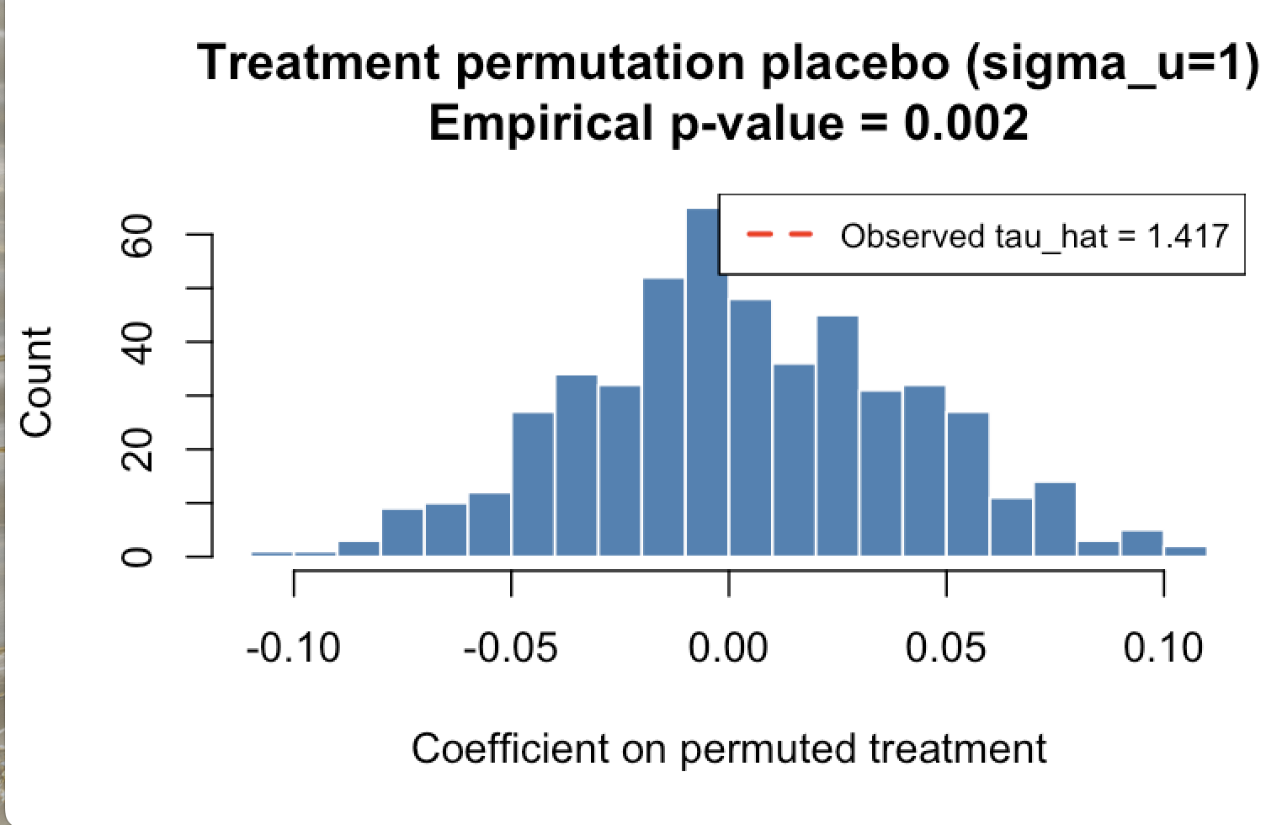
what the null hypothesis is in the permutation test, (b) what it means if the observed estimate is extreme relative to the permutation distribution, and (c) one way
- The null hypothesis is that there is no relationship between the treatment and the outcome, indicating the treatment should be randomly assigned.
- If the observed estimate is extreme relative to the permutation distribution, it indicates that this value is impossible in the context of the distribution, since it should be a normal distribution under the null hypothesis to suggest that this is a product of randomly assigning the treatment. Also, the p-value further suggests that the null hypothesis is rejected.
- The reason for using a placebo is to create a situation without a true effect to help understand whether the error occurs from pipeline problems. If the results indicate the placebo still works, that means there is an error of the pipeline problem.

